**CHAROTAR UNIVERSITY OF SCIENCE & TECHNOLOGY**

**U. & P. U. PATEL DEPARTMENT OF COMPUTER ENGINEERING**

**DEVANG PATEL INSTITUE OF ADVANCE TECHNOLOGY AND RESEARCH**

|  |  |  |  |
| --- | --- | --- | --- |
| **ID:** | 19DCE056 | **Name:** | Yash Kavaiya |
| **Subject Code:** | CE246 | **Subject Name:** | Database Management System |
| **Date of Exam:** | 1st May, 2021 | **Batch:** | C |
| **Contact:** | 9537601879 | **Question Set:** |  |

**PRACTICAL – 1**

**AIM: Perform following queries.**

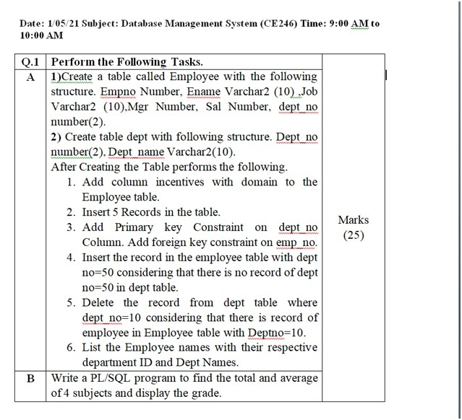

**COMMANDS:**

CREATE TABLE EMPLOYEES(EMP_NO NUMBER, E_NAME VARCHAR2(10), JOB VARCHAR2(10), MGR NUMBER, SALARY NUMBER, DEPT_NO NUMBER(2));

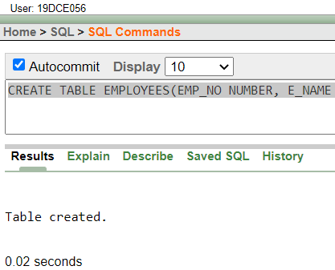

CREATE TABLE DEPT(DEPT_NO NUMBER(2), DEPT_NAME VARCHAR2(10));

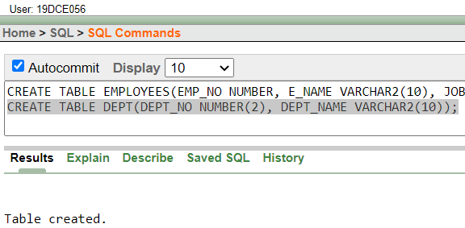

ALTER TABLE EMPLOYEES ADD INCENTIVES NUMBER;

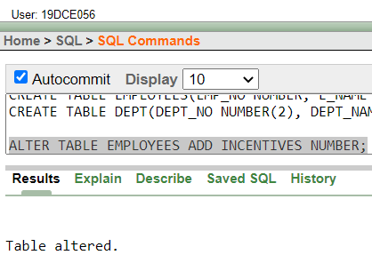

INSERT ALL

INTO DEPT VALUES(20, 'AI', 102)

INTO DEPT VALUES(50, 'ML', 103)

INTO DEPT VALUES(10, 'CN', 104)

INTO DEPT VALUES(40, 'FINANACE', 105)

INTO DEPT VALUES(30, 'WEB', 106)

SELECT * FROM DUAL;

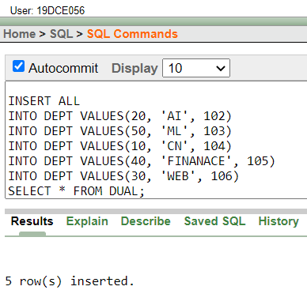

INSERT ALL

INTO EMPLOYEES VALUES(102, 'YASH', 'SDE', 201, 5000, 20, 0)

INTO EMPLOYEES VALUES(103, 'YUG', 'WEB_DEV', 202, 7000, 50, 0)

INTO EMPLOYEES VALUES(104, 'TANMAY', 'AI', 203, 10000, 10, 0)

INTO EMPLOYEES VALUES(105, 'DARSHAN', 'SDE', 201, 5000, 40, 0)

INTO EMPLOYEES VALUES(106, 'MEET', 'WEB_DEV', 202, 7000, 30, 0)

SELECT * FROM DUAL;

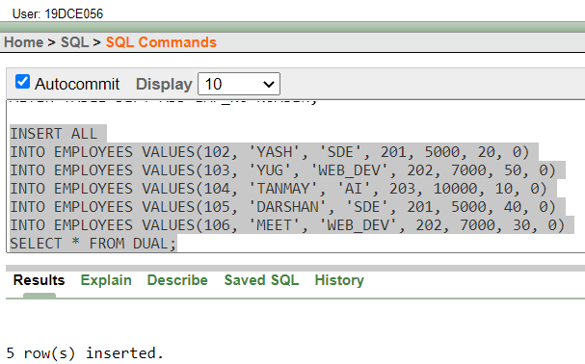

ALTER TABLE DEPT ADD PRIMARY KEY(DEPT_NO)

ALTER TABLE EMPLOYEES ADD PRIMARY KEY(EMP_NO);

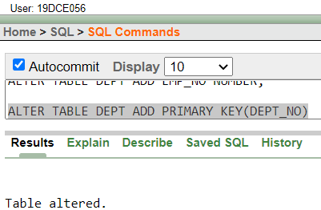

ALTER TABLE DEPT ADD FOREIGN KEY(EMP_NO) REFERENCES EMPLOYEES(EMP_NO)

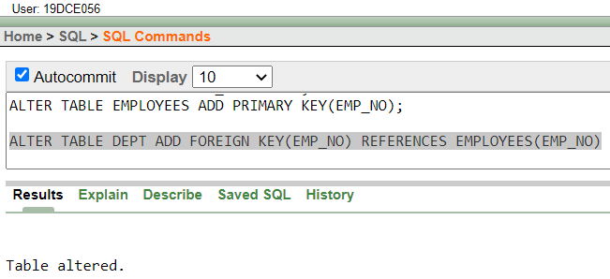

INSERT INTO EMPLOYEES VALUES(103, 'YUG', 'WEB_DEV', 202, 7000, 50, 0)

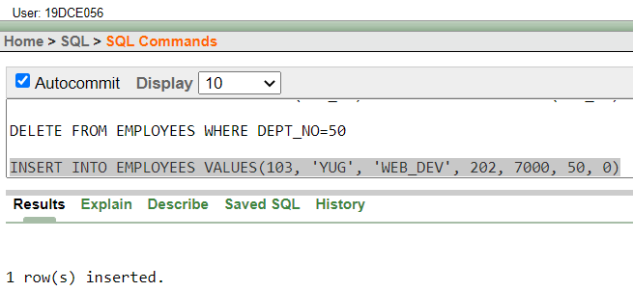

DELETE FROM DEPT WHERE DEPT_NO=10

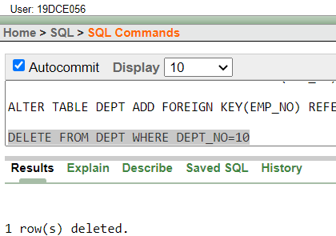

SELECT EMPLOYEES.E_NAME, EMPLOYEES.DEPT_NO, DEPT.DEPT_NAME FROM EMPLOYEES JOIN DEPT ON EMPLOYEES.DEPT_NO=DEPT.DEPT_NO

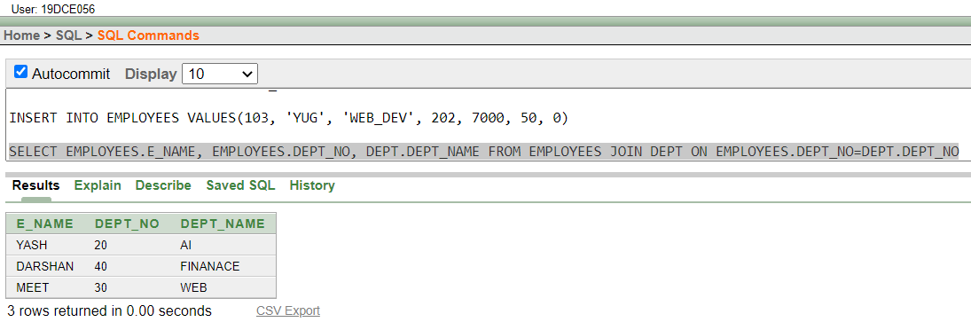

**PRACTICAL – 2**

**AIM: Write a PL/SQL program to find sum and average of 4 subjects and display grade.**

**CODE:**

DECLARE

SUB_1 NUMBER;

SUB_2 NUMBER;

SUB_3 NUMBER;

SUB_4 NUMBER;

TOTAL NUMBER;

AVERAGE NUMBER;

GRADE VARCHAR2(1);

BEGIN

-- USER SHOULD ENTER MARKS OUT OF 100

SUB_1 := :ENTER_SUBJECT_1_MARKS;

SUB_2 := :ENTER_SUBJECT_2_MARKS;

SUB_3 := :ENTER_SUBJECT_3_MARKS;

SUB_4 := :ENTER_SUBJECT_4_MARKS;

TOTAL := SUB_1 + SUB_2 + SUB_3 + SUB_4;

AVERAGE := TOTAL/4;

DBMS_OUTPUT.PUT_LINE('Total Marks are ' || TOTAL);

DBMS_OUTPUT.PUT_LINE('Average of total Marks are ' || AVERAGE);

IF TOTAL > 350 THEN

GRADE := 'A';

ELSIF TOTAL > 300 AND TOTAL < 350 THEN

GRADE := 'B';

ELSIF TOTAL > 250 AND TOTAL < 300 THEN

GRADE := 'C';

ELSIF TOTAL > 200 AND TOTAL < 250 THEN

GRADE := 'D';

ELSIF TOTAL > 150 AND TOTAL < 200 THEN

GRADE := 'E';

ELSE

GRADE := 'F';

END IF;

DBMS_OUTPUT.PUT_LINE('Grade Is ' || GRADE);

END;

**OUTPUT:**

